Tad A. Jameyfield
English 104
Nicole Williams Section 69
February 28, 2009
Opening the Box: Defining Space
Walking through the vast, open, dark, and somewhat sinister courtyard from Lafollette Complex to Irving Gym after a later dinner, a foreboding feeling of nothing good was slipping through the cracks of head, stirring my thoughts into a concoction of doubt. Maybe Irving was going to be filled with more stereotypical jock characters. For that I do not know, and I will have to face the future when the truth appears.
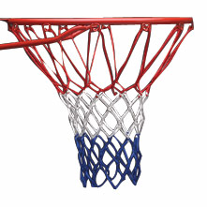
Slowly I stumbled with my separated shoulder through the double doors to find a long brown haired, and slightly skinny girl work at a table you would normally find at a Sunday breakfast at some local church. Politely, she took my identification card and said “Here you go!” with a bright smile on her face. This feeling swayed the dark doubts about my research tonight. The background was set for an interesting experience.
Figure 1 A Basketball Hoop and Net
Walking into Field House Sports building in Irving Gym, the first characteristic I noticed was the high contrast in lighting compared to the cold night sky hovering over Muncie, Indiana. The lights were very bright, which allows the players or joggers to see most things in the atmosphere of sight to possible prevent injury, allow better sight for the goals of players (such as the basket), and possibly to maintain each person’s awareness of the space.
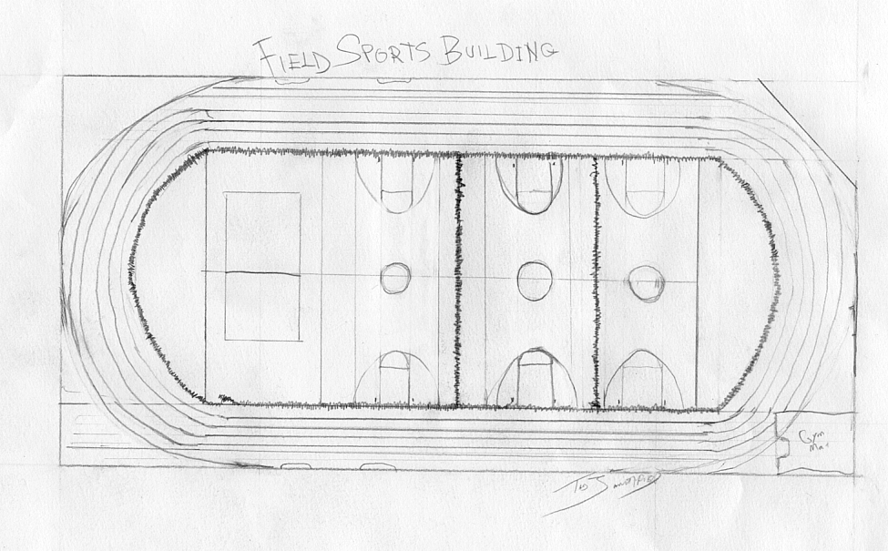
Defining the space within the one room, four walls, a ground and ceiling, attached building to Irving Gym might appear to be an easy task at the first glace, but one can notice spaces within spaces. A black divider net is runs the perimeter of all four courts, and two divers are placed between courts one and two and courts two and three. Courts three and four were not separated, causing a presumable mess between the volleyball players on court four and basketball players on court three. The first court straight ahead of the check in desk you would walk past when first entering, is primarily used for basketball.
Figure 2 An Aerial Map of the Field Sports Building Hand Drawn by Tad A. Jameyfield
Another feature one notices about the Field Sports Gym initially is the large amount of volume contained in this box. The ceiling plane is about 30 to 40 feet tall and exposes the structural beams which hold the roof together. After viewing the ceiling, the eye is drawn downward towards the walls, which look to be steel and are primarily off-white with a maroon stripe bisecting the white in the middle section. From this point, the eye falls upon court number one again.
Out of each visit to the gym, I found that court number one is always occupied by male, mostly white but a handful of African American, Hispanic, or Arab, basketball players. Walking past court number one, I found myself being stared at and closely watched by the employees walking around the track, which encompasses the rectangular perimeter of the four courts. I was not clear on why these two smaller, white males were looking at me like I was up to no good. These employees must have been near my age of 19, and were wearing red, BSU Athletics polos. One had a nametag (I did not catch the name as I walked by), and one did not. Maybe the one without the nametag was lazy and incompetent, thus forgetting his nametag. Both stares happened simultaneously. My assumption was that I was in a sling, was wearing casual and not athletic shoes, and wearing jeans while carrying a notebook. I later figured they were curious and judged my behaviors because of my appearance. The employees’ glares veered my direction toward the first court and I continued walking down the dusted and faded maroon track, which had a gritty and granular surface.
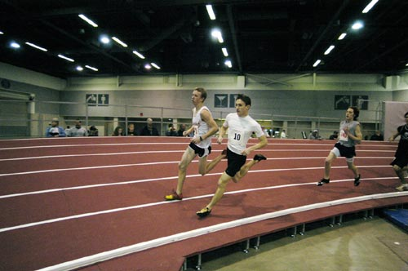
The track was five lanes wide on each straightaway and five lanes wide on each turn, which perplexes me. Won’t runners competing in a race get cut off? Maybe only five runners compete for each heat of each race. The track is divided like a normal indoor track with white lines. The straightaway closest to the north wall of the building runs into a large, red pole vaulting mat.
Figure 3 An Indoor Track
Continuing walking down the straightaway, I found a team of attractive girls playing soccer all dressed in pink t-shirts. I stood to view the teams for a while and noticed the opposing team was dressed in no uniform color. These girls had attractive, athletic bodies and also had been tanning. Most were blond haired and relatively short.The pink shirted girls seemed to be very intense in their game and, according to a hand flipped scoreboard held by a referee sitting in a chair in the 8th lane of the straightaway, appeared to be mauling the other team 4 to zero. While studying the referee and his ancient technique to keeping score, I was distracted when I heard some man shout from court number three, “He packed your ass!”
Glancing my direction over to court number three, I saw a very intense pick-up game of basketball occurring. The ethnicity of the players was very similar to court number one, but the intensity much higher. The players, whom none I recognized, were extremely focused and said very little on the court. The exception was in a tall, African American who seemed to be the alpha dog of his team, named Chris. He called each player not by name but by a grunt or a “hey!” Bringing the Wilson Jet leather ball up the court most times, I assumed Chris to be the point guard.
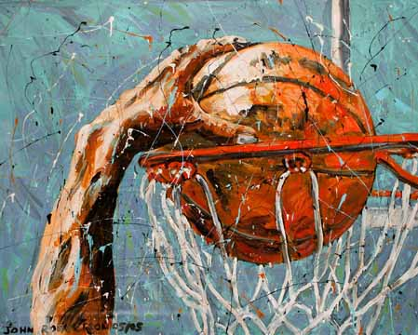
Chris would pass most times to a tall and lanky white kid named Brian, who wore a black Purdue t-shirt that was loose fitting and glided somewhat like a cape when he would drive to the basket. Brian missed about half of his drives and lay-ups and when the opposing team grabbed the ball, the crowd of eager players standing on the sidelines would shoot at the empty basket.
Figure 4 Dunking, a common maneuver in basketball depicted in an artistic view
The sideliners would converse amongst themselves; speaking of friends they knew playing for Division I colleges, specifically Purdue. I wonder if these kids were speaking of Robbie Hummel or E’Twaun Moore, who are originally from my area of Northwest Indiana.
The sideliners were definitely different that the players on the court. The court players seemed to be stoic and possibly complete jerks. I was lead to assume this because no one except Chris was yelling, or even cheering after they scored a three point shot.
One Caucasian player, whose name I could not comprehend through the grunted yelling, wore shoes with laces untied, but in a stylish sense. He could have easily tripped over himself within seconds! He was about average height, had very short black hair, and had a very slovenly appearance. His shirt was tucked in at the front and out in the back. Also, the white t-shirt was clearly too big for him and I pondered on why could he have possibly chosen this style of clothing to wear. Maybe he didn’t care what he looked like, or what people’s perception of him was. I thought he looked ridiculous, and the style didn’t help too well when his black shorts kept sliding down his legs from sagging them too far off his rear.
One thing that players on and off the court did perform was shooting around with two or three balls at the most between game sets. The players seem to bond closer than when the games are in play. By holding small conversations between small sects of two to four people, occasional laughter, and rebounding and shooting only two or three balls compared to the twenty some kids on the court, the players could socialize.
Along with the gaps between the games and shooting around, one other tie between the two groups of players was that they all dressed and looked very similar. All wore slightly, but not ridiculously baggy t-shirts of various sports teams, multicolored athletic shorts, and Nike basketball shoes. I had found only three players within the two sets of games I witnessed that were wearing other shoes. The look also was completed by hairstyle, which was either a one inch clipper cut or very close in that length. Based on appearance, the players from both sections should socialize well, but there was still one limitation holding the players back.
The lines spelling out a box seemed to be the constraints of socialization. Once the game was in session, the players would stay inside the rectangle and the sideliners would stand and stare unanimously at the ongoing game and hold very brief conversations about the next set of games which the sideliners would rotate in for the losing team of the current game. These conversations would include bragging about dunking over Anton’s head or what each player was going to do in the next game, such as scoring or trash-talking other players currently playing.
The conversations also pertained to partying and girls. Many conversations I picked up on were about how last night’s sexual encounter at Christine’s places was, or how drunken one player was last Thursday night. Since it was Tuesday, I laughed at the thought of the player who had to brag about his drinking escapades and thought to myself, “He must be looking for attention or acceptance from someone.” The ironic fact was that this kid was the same kid who dressed sloppily in the white tall tee.
My observations bring me to ponder if the two groups can ever come together on the court. I know that off the court, the players of opposing teams shake hands or greet each other excitedly after the game. I don’t believe, based on playing three years of men’s recreational basketball with friends from high school, the competition between friends can ever deteriorate while on the court. I always enjoyed beating my friends, no matter how close, and having bragging rights the next day when I saw my friends in classes. Being that the goal of the game is to win, competition will always be a factor. Players that know each other or those that are unacquainted with each other will not differ in the competition level. The players will play to win and will put aside friendship and most aspects of the fun of the game in order to achieve that goal.
Observing the court number three game sets sucked my attention away from the rest of the gym which seemed to filter out closer towards 10:00 p.m. The games proceeded for another half hour, which is when I began to notice more weird looks coming from different players. I bet I was an easy target wearing a sling and dressed in jeans, sitting on a red wrestling mat writing notes about their behavior. The thought made me chuckle inside and made me think to myself, “Wow I really must have gone insane thinking about people socializing when I have so much homework due in the next week.” At this point I began to exit the gym as the sets of games continued on court number three. As I left, I noticed several sideliners grab their khaki colored Hollister Coats and follow about 15 feet behind me.
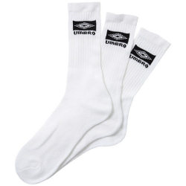
When exiting the gym, I saw the same skinny brown haired girl whom I exchanged my identification card for my admittance to the Field Sports Building. About 20 feet were left approaching the worker before I notice the giant Track and Field Record Board hanging over the entrance/exit doors. The board read just that: Ball State Track and Field Records. I pondered about my track career and how if I might have tried out for the track team at Ball State, I might have made junior varsity. The thought came and went as did my balance when I tripped due to the bright lighting and focusing on the board above me.
Figure 5 Gym socks can either be very clean, or very sweaty
As I turned one last time before exiting the building, I looked at the entrance and took a breath of the stale, dry pre-consumed air. I still found that the first sight one would see was the net facing the visitor upon arrival into the gym. I thought of the players from court number three once more, and how they must be tired because between twenty men and ten players on the court at all times, the players must be tired. I grabbed my identification card and smelled my jacket. I smelled like a heavily chlorinated gym sock that was worn only once by a runner for cross country practice: salty and sweaty, but slightly covered by a hint of Clorox Cleaner. After seeing the competition and thinking about the game of basketball again, I wanted to play more than ever.

