Where We Go From Here...Website Layouts

Click...loading...flash...information appears. The layout of a website is cruicial to the function of the site. Think about your room.

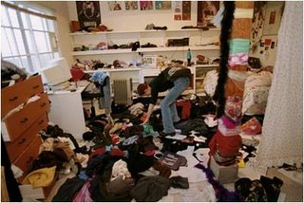
If you live in a constant cluttered state, leave drawers and furniture displaced, or have mass amounts of clothes thrown in a random array, finding a particular item could nearly take an escavation team.
Organization and flow to a website is like a vacuum cleaner to that room. Certain colors, shapes of tabs, and placement of links that open to other pages are things to think about when constructing a website.
Being able to go from one page to the next and navigate with ease and having the convienience of not thinking too hard to find the something you are looking for is the basis of a functioning website. The Website Houndout explains the process of creating a functional website.
I agree with the website and would also add that the guidlines that are given in the handout are simply just that...guidelines.
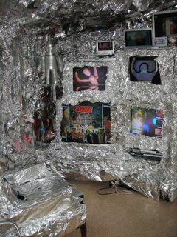
Truly good websites, in my opinion, present a functioning finished product that is attractive, creative, and original. Each website should reflect the meaning they are trying to convey to the reader.
In constructing your website, you should take in consideration where the eye will look to for navigation of the site and proper function basics, but the site should also reflect the architect.
You are creating this website, so your own ideologies and beliefs should be present in some way. I think that the individuality on a website screams just as loud as the function, but the two are no more or less than each other.

