Stike! We got Something Here...
The smells, the sights, the old crappy bowling alley that made so many memories for the writer. These all contributed to the image produced from the essay IResearcher.

The author captured the spirit and theme of the bowling alley through text rhetoric, which made the experience feel first hand to the reader. The assumptions made about families was intersting.

I think that just describing the place which is being described is not enough. Drawing conclusions from assumptions about family situations, social class, veteran war stories, and other scenarios can provide a vivid image for the reader.

So mu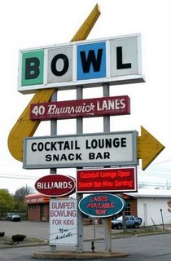ch more than description accounts for the impression left on the reader. The essay was a little scattered, but I could understand that this was the writer's thought process. I think that the writer should have mentioned that she had never been to any other bowling alleys other than ones in her region.

People have different experiences in different places all over America, or the World. So the experience held in one bowling alley may not be the same in the a different area.

This subject was touched on when describing the paper-pencil scoring system. The archaic tallying system was still used in the alley, which could make readers assume that the lanes are older as well as the building.

The essay was written definitely for sensory stimulation. I felt i could almost smell the bowling alley from the visual descriptions given by the writer.

I enjoyed the essay and think that, as an early draft, is a good start visually and creatively.

