Tad Jameyfield
Essay 1
Professor Williams
English 104
The Structure behind the Leather
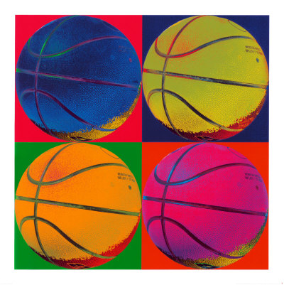
Pounding my head and pulling my hair seemed to be my only solution to exploring the vast groups and topics my ethnography research paper could be based upon. Suddenly the pounding ceased, and a new side of the frustration was felt. The pounding was now dribbling. An epiphany struck me as if I was a metal rod in a lightning storm. The electric current pulsated down my veins and before I could speak, the topic was written on my notebook: basketball.
Figure 1Basketball Art
Researching basketball is a broad topic, so I narrowed my study down to a team and league I initially wanted to belong to. Interested in the West Side Basketball Association, and more specifically the Hurst 3 Hoopers, I began my thought process. The Westside Basketball Association is an intramural basketball league for Lafollette Hall residents, and the Hurst 3 Hoopers is the organized recreational basketball team of the third floor of Hurst Hall within Lafollette. I had previously been involved with recreational and high school basketball teams, and understood that even though a game is created for enjoyment, the competition can overthrow any feelings of carefree fun.
So many questions raced around y head that I briefly felt faint. Do these teams compete like high school basketball or is the West Side Association just a recreational league created for fun? How does the team behave with each other? Will the team actually run offensive and defensive plays? Will the teams run a zone defense or man-to-man defense? All of these questions have a common bond in that the questions ask how do this league and the team function in comparison to organized scholastic basketball leagues? The queries seem to pile on, but all have a common bond within the team function and structure.
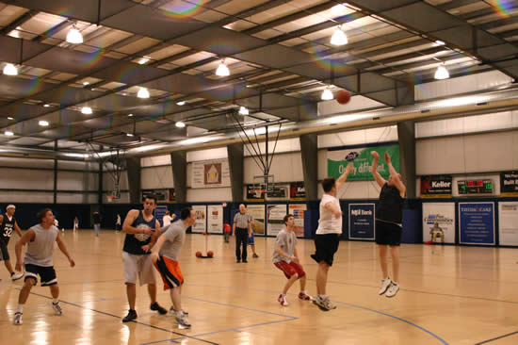
I find myself pondering about teams and how people function within larger groups of people. I know within teams, the structure is comprised of certain people for certain roles. Leaders, followers, rebels, and the average, apathetic players with no apparent care for the game will all be found within this skeleton of the team. I live on the same floor as all of the Hurst 3 Hoopers teammates, and see them in their living and dwelling patterns.
Figure 2 A Pickup Game of Recreational Basketball
The team members all live within the same floor as I do, so I can observe how the players interact off the court as well as on the court. The teammates could carry their attitudes about the sport into their studies or living patterns. Observing the teammates living could possibly affect my views on how they play basketball, or how I view the people at all for that matter.
The teammates are another complete fascination. Who will become the leader? Who is the role model? Are there more than one? Who is liked and disliked? I am sure that I will find cliques of kids only working for the friends within the cliques. The experience might be like a high school recreational basketball league where the friends on the team exclude other “non-friends” in certain offensive and defensive plays, chants and handshakes, inside jokes, and time spent off the court. The upsetting and tangled feeling of a stomach ache could be felt by a non-member wanting to gain further acceptance from his teammates and wanting to quit because of the aforementioned factor.
The possibility of having a team “jerk” is also apparent. One player might think higher of themselves and look down upon the rest of his teammates for certain motives. Being too slow, not identifying with one particular clique, not being able to play well are all possible intentions for a certain ignoramus to walk higher than the rest of the team.
My experiences with recreational and scholastic basketball have been both exciting and painful. I played organized basketball for most of my life and was playing in leagues such the Catholic Youth Organization and the town biddy ball leagues for quite some time. Playing one year of high school basketball, I focused my time in track and field and cross country and also in music when forming a band with several friends. Although I did not play basketball for the Highland High School, my past high school, I participated in recreational leagues for the remaining years of high school with friends and had a fun time. The fun was also balanced by high competition and humiliation I school after a loss.
Arriving to college I was recruited to play for the Hurst 3 Hoopers by Several residents and my resident assistant. I unfortunately declined for I knew my work load for school was significant and would also be a part time worker in dining services. I still kept in contact with my resident assistant about the Hurst 3 Hoopers and their current playing matters.
Mo Harding, my resident assistant, has discussed how much the team means to him and how the team is hurting after the team’s leader, Shaggs, left at the semester to return home. The loss of the team leader has disrupted the balance of confidence and comradeship. The team seems to, according to Mo, slip in a bad direction with the sport and their studies.
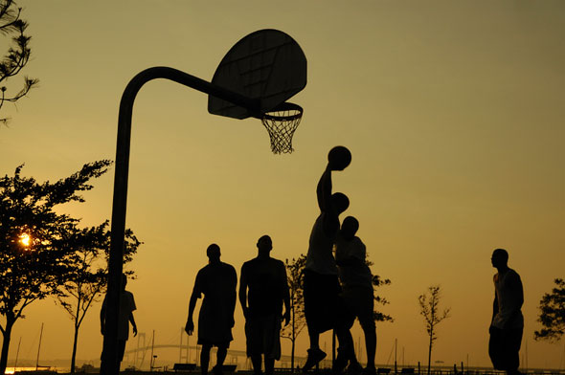
Knowing previously that the Hurst 3 Hoopers have study tables, I am wondering about their grades. I can picture a mixture of assumptions about the players and their study habits. Sure, the intelligent members of the team can both play well and attain good marks on a philosophy exam, but are there members that cannot juggle the three balls of life in school, life on the court, and life outside of the court and school? Having a rift between players with good grades and bad grades can be a central argument to succession. Why this player’s grades are so high and why does her play so well, or vice versa? Why are this player’s grades so low and his intensity and ability to perform as a basketball player so high, or vice versa? These questions lead one down a path full of individualistic assumptions about each player on the Hurst 3 Hoopers and the player’s outlook on life.
Figure 3 Park Pickup Game of Basketball
Members of the basketball team might be more apathetic than others. Some members might find themselves less skilled than others and instead of staying after practice and becoming one with a tan, leather ball, go home to sit and complain that their inadequacy is not their fault. Picturing a roomful of apathetic players almost makes me have a stress related migraine from trying to motivate the players to play to their fullest potential and not be kept down in the dirt because someone told them they belong in the soil. I want to see which players care about life on the court and who does not care about the game and the team chemistry. From this point, I can draw conclusions on certain player’s apathy level and draw further conclusions based on socioeconomic status, race, religion, upbringing, and so on.
Focusing on the team aspect, I want to see how the team bonds in how they compete against other teams. Hurst 3 Hoopers might have special cheers in which they use to demoralize and humiliate other rival teams. The jeers might pertain to the level of skill other opposing players have or making crude sexual remarks about their sexuality. The name calling and disgust for other teams and other individuals on those teams could possibly gather the Hurst 3 Hoopers closer by having a common hatred towards other teams in West Side Basketball Association and promote team bonding.
Figure 4 Teamwork Illustrated in Puzzle Form
The factors pertaining to the function of the Hurst 3 Hoopers fascinates me for various reasons. The psychology of the team sport has caught my interest since I have been involved with both recreational sports and school sports in grade school, middle school, and high school. I have found myself pondering on why the team acts the way they do during the time outs and half times of games and walking home from practices.
I want to experience this culture from another perspective. Not as a player, but a bystander I could possibly see other views about the team. During the games I never had time to answer any of these questions relative to the function of the team, and now from another view I wouldn’t have such biased and influenced views. A different perspective of the group might bring about a new respect or abhorrence for the sport and league.
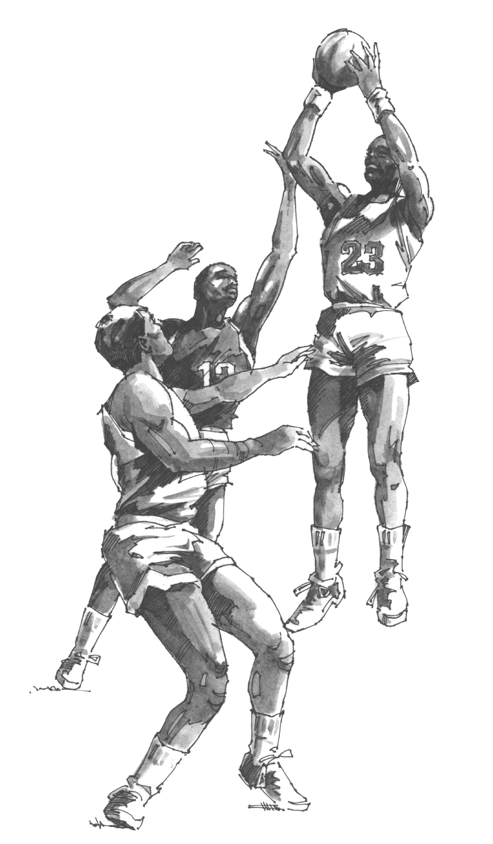
A new perspective will also embed particular sensory details within the memory of the observation. The smells of the leather ball or the gym might trigger a thought or an opinion of the league. The sounds of the constant pattering of balls being dribbled and obscenities uttered during contact with other players could also be another device to further support the visual rhetoric to the memory. The touch of the balls or the friction of the gym shorts swiping past each leg can launch the mind into reminiscing about previous games. The sensory overload will definitely contribute and support the visual rhetoric both in image and in text.
Figure 5 A Watercolor Sketch of Michael Jordan, the Greatest Basketball Players to Step on the Court
An experience waiting to happen, observing the subculture of the Hurst 3 Hoopers will fortify my experience as a basketball fanatic, player, and observer. In my pursuit of knowledge of the team, the team’s function, and what roles each player conforms to and why they conform to these roles, I hope to understand why these young adults choose this sport to play and how to apply the knowledge gained from the experience to my own life. The topic of basketball is fascinating to me, and to parallel the game and the team to my life, I could relate with the topic and further explain teamwork and basketball to others. Others may do whatever they need to with the knowledge, but I will walk more wise and able to explain this experience to myself.

